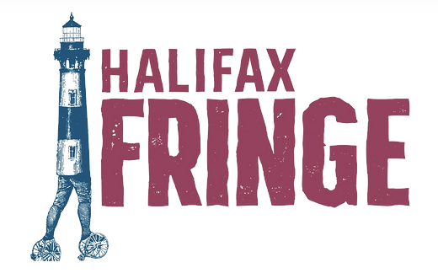

**Halifax Fringe Festival is seeking a   
2025 Production Manager**

**Application Deadline:**  Tuesday June 10th 2025

**Position Timeline:**  June 17 - September 15 2025   
**Compensation:** $8000 (approx $29/hour)

**Location:**  Kjipuktuk (Halifax)

___________________________________________

The Halifax Fringe Festival is an annual uncensored, unjuried, international arts festival. The Fringe is 12 days, with over 60 productions, performing at 10+ venues!   
  
The Halifax Fringe Festival’s mission is to create a space for everyone to express themselves through performance. We envision a home for anyone to tell their story. We strive to empower artists and audiences. By prioritizing our values of being unjuried, uncensored, equitable, and accessible, we aim to create a space that welcomes differences and celebrates expression. We are a non-profit association run by a volunteer board.

**___________________________________________**

Halifax Fringe Festival seeks a Production Manager to join our 2025 team!

The Production Manager will be responsible for overseeing the technical and production elements at all venues for the 2025 Halifax Fringe Festival - a large-scale, international performing arts festival in Kjipuktuk (Halifax). The successful candidate for this position will have great problem solving and strategic thinking skills, be able to work independently as well as in a leadership role, and be available to work weekends and evenings during the Festival (August 27-September 7).

## **RESPONSIBILITIES**

Under the direction of the Executive Director and Board, the Production Manager will be responsible for:

* Working with the Executive Director to confirm the festival schedule
* Working with the Executive Director to confer with venues and determine if any additional venues are needed
* Looking over technical information provided by artists and communicating technical needs with venue technicians and venue rental spaces
* Escalate incidents and feedback to Halifax Fringe Executive Director
* Reconciling cash boxes each night from August 27-September 7
* Being available to artists to answer all questions regarding show requirements, technical needs, and venue questions
* Helping to facilitate a positive experience for both artist and venues in rental spaces to coordinate a smooth festival experience
* Provide accurate information and directions to audiences and visiting companies
* Respond quickly and kindly to questions, requests, problems, or complaints

The Production Manager reports to the Executive Director, and will work closely with the venue and operations staff, board members and volunteers.

**HOW TO APPLY**

Please submit a current CV, a Cover Letter on [HalifaxFringeFestival.ca](http://halifaxfringefestival.ca) job application form or by emailing [sara@halifaxfringe.ca](mailto:sara@halifaxfringe.ca) with the subject line “Production Manager”

**The deadline to apply is Tuesday June 10th, 2025**

We recognize the over-representation of white, cisgender, able-bodied voices in theatre. Halifax Fringe prioritizes the contributions and perspectives that individuals from underrepresented communities bring to our festival, we strongly encourage applicants to self-identify in their cover letter.

We prioritize creating a work environment that is supportive for all Halifax Fringe employees and considers their access needs. Please reach out at any point during the application process if you would like assistance.